

**ATAR PHYSICS**

**TEST 5 2021**

RELATIVITY, PARTICLE PHYSICS AND COSMOLOGY

**NAME**: _________________________

**TEACHER**:______________________

**MARKS**:  **/54**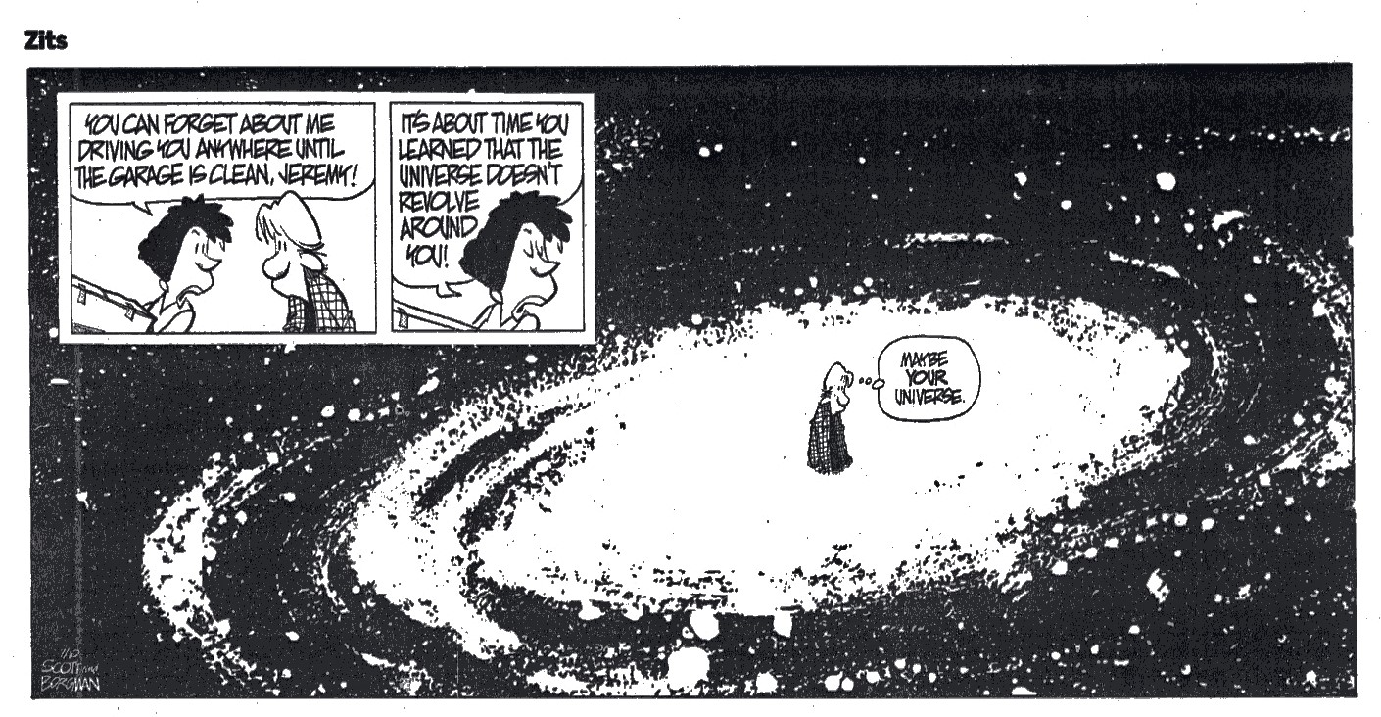

**Instructions:**

**Do not turn this paper over until you are told to do so**

* **Answer all questions.**
* **When calculating numerical answers, show your working or reasoning clearly. Give final answers to three significant figures and include appropriate units where applicable.**
* **When estimating numerical answers, show your working or reasoning clearly and give final answers to a maximum of two significant figures.**
* **Show working out steps neatly, logically and clearly to score full marks**
* **An approved scientific calculator may be used**
* **Write with a blue or black ink pen. You may use a lead pencil to draw diagrams.**

**Question 1 (8 marks)**

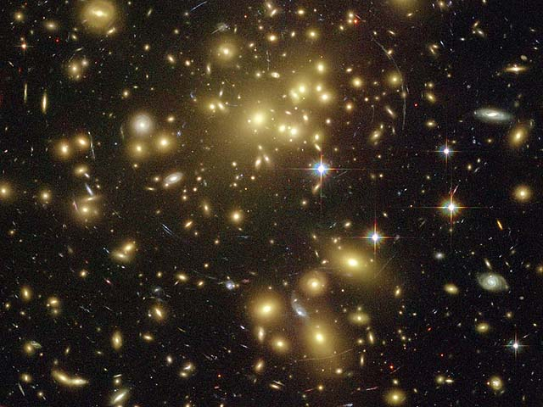

The graph below is representative of the findings of Edwin Hubble,

who researched cosmological concepts that led to the Big Bang

Theory.

1. Describe the relationship that is observed within this graph. (2 marks)

|  |
| --- |
|  |

1. The Steady State Theory preceded the Big Bang Theory. The Steady State Theory lost acceptance in the scientific community based on the work of Hubble. Explain how the relationship shown in the graph supports the Big Bang Theory and is in contradiction to the Steady State Theory. (3 marks)

|  |
| --- |
|  |
|  |
|  |

1. Hubble’s law is described by the following equation:

Where is the recessional velocity of a galaxy and the distance of a galaxy.

Use the graph to calculate a value for Hubble’s constant (), which has units km s-1 Mpc-1. You must add construction lines to the graph to show how your answer was obtained.

(3 marks)

: ________________________ km s-1 Mpc-1

**Question 2 (4 marks)**

In 2019, a dark matter detector that had been running for two years has not detected any dark matter but has detected 126 incredibly rare cases of xenon decay. In xenon decay, a pair of electrons are captured simultaneously by two protons and emit two neutrinos.

Confirm whether this reaction is possible by checking conservation of baryon number and lepton number.

**Question 3 (8 marks)**

A particle consisting of four quarks and one anti-quark is called a pentaquark. Pentaquarks were theorised as early as 1964 and the first evidence of their existence obtained in 2003. However, it wasn’t until 2015 (and again in 2019) that enough data had been gathered to make a genuine claim that a particle had been discovered that matched the theoretical properties of a pentaquark.

1. Show, via a calculation, that a pentaquark has a baryon number of +1. (2 marks)
2. The equation below describes the formation of a pentaquark. A lambda baryon, () decays via a boson, forming a kaon minus, () and the pentaquark, ().
   1. State which fundamental force is responsible for mediating this decay. Justify your choice. (2 marks)

Force: _______________________

|  |
| --- |
| Justification: |
|  |
|  |

* 1. Show that electric charge is conserved during this decay. (2 marks)

_____________________________________________________________________

* 1. Show that baryon number is conserved during this decay. (2 marks)

_____________________________________________________________________

**Question 4 (4 marks)**

Arrange the following list of matter in order of formation in the universe according to the Big Bang Theory.

* Baryons, Nuclei, Light elements, Stars, Quarks and leptons, Heavy elements

1. **_______________________ (formed first)**
2. **_______________________**
3. **_______________________**
4. **_______________________**
5. **_______________________**
6. **_______________________ (formed last)**

**Question 5 (4 marks)**

A single charged sodium ion (Na+) is moving at 1250 m s-1 within a 0.866 T magnetic field as shown below. The sodium ion has a 3.82×10-26 kg mass.

A single charged sodium ion (Na+) is moving at 1250 m s-1 within a 0.866 T magnetic field as shown below. The sodium ion has a 3.82×10-26 kg mass.

X X X X X X

X X X X X X

X X X X X X

X X X X X X

V

1. On the diagram above, draw the path the sodium ion follows. (2 marks)
2. Calculate the radius of the ion’s movement. (2 marks)

Answer: __________________ m

**Question 6 ( 7 marks)**

An alien observer on the planet Vulcan is witnessing a nearby battle between the United Federation of Planets and the Borg. The alien sees the Starship Enterprise chasing a Borg Cube.

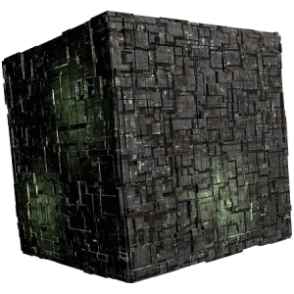

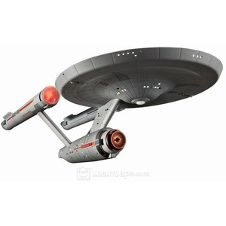

* + - * 1. He measures the Enterprise to be travelling at 0.90c and the Borg Cube to be travelling at 0.80c. Calculate the velocity of the Enterprise relative to the Borg cube.

(4 marks)

* + - * 1. The Borg ship fires a phasor beam (an extremely high frequency beam of light) at the Enterprise.

Determine how fast the crew of the Enterprise will see the beam travelling towards them

As predicted by Newton:

(2 marks)

As predicted by Einstein:

(1 mark)

**Question 7 (8 marks)**

In the science fiction series *Willo Trek*, Captain Taylor decides to test his brand new starship with a quick trip from Earth to Pluto.



During the trip, the starship travelled at a speed of 0.98*c*

(*c* = speed of light). Captain Taylor’s identical twin brother, Doc Taylor, who remained on Earth, measured the total travel time to Pluto to be 5.35 hours.

1. As seen by Doc Taylor on Earth, calculate the distance from Earth to Pluto in kilometres.

(2 marks)

1. As seen by Captain Taylor in the starship, calculate how far his journey would have been.

(2 marks)

1. What is the journey time as experienced by Captain Taylor?

(2 marks)

1. If it was possible for Doc Taylor to see the clock on the spaceship, how much time would he observe to pass on the spaceship during the trip?

(1 mark)

1. If it was possible for Captain Taylor to see Doc Taylor’s clock on the Earth, how much time would he observe to pass on the Earth during the trip?

(1 mark)



**Question 8 (3 marks)**

The standard model of particle physics proposes that heavy sub-atomic particles (hadrons), such as the proton or neutron, are actually composite particles made of different combinations of more fundamental particles known as quarks. There are 6 quarks whose properties are listed below.

|  |  |  |  |  |  |  |  |
| --- | --- | --- | --- | --- | --- | --- | --- |
| **NAME** | **SYMBOL** | **Charge (Q)** | **Baryon Number (B)** | **Strangeness (S)** | **Charm**  **(c)** | **Bottomness (b)** | **Topness**  **(t)** |
| *Up* | u | e |  | 0 | 0 | 0 | 0 |
| *Down* | d | e |  | 0 | 0 | 0 | 0 |
| *Strange* | s | e |  | -1 | 0 | 0 | 0 |
| *Charmed* | c | e |  | 0 | +1 | 0 | 0 |
| *Bottom* | b | e |  | 0 | 0 | -1 | 0 |
| *Top* | t | e |  | 0 | 0 | 0 | +1 |

State the quark composition of the following hadrons: (3 marks)

(i) the Lamda-zero Ao , baryon with Q = 0, B = +1, and S = -1 and c = b = t = 0

(ii) the charmed Xi (Ξ+c) baryon, with Q = +1, B = +1, S = -1, c = +1 and b = t = 0

(iii) the D-zero meson, with Q = 0, B = 0, c = +1 and s = b = t = 0

**Question 9 (8 marks)**

Beta decay is the ejection of an electron from the nucleus of a radioisotope. The beta particle (electron) speed can vary, but for this question, assume they are ejected at 0.990c.

A beta particle is ejected from the nucleus of an atom:

1. Calculate the total energy of the beta particle. (3 marks)

Answer: _______________ J

1. Calculate the quantity of mass lost by the nucleus due to the beta decay event..

(2 marks)

Answer: _______________ kg m s-1

1. Calculate the magnitude of the momentum of a beta particle as measured from the reference frame of the nucleus.

(3 marks)

Answer: _______________ kg

**END OF TEST**